#10) Write a blog post to explain the results from a business perspective

Regardless of the motive behind people's choice of investment, it comes with the undeniable fact that investing should be done wisely. This is why I will be covering a few aspects of investment here.

I first, look at economic cyclicality. Economic cyclicality refers to whether or not there is a strong correlation between economic activity and the stock price. A lot of the stocks are economically cyclical, which is to be expected, and the implication it brings to portfolio building is that in economic downturns, those stocks prices are more likely to plunge. The graph below shows that while they are few (approximately 10% are non-cyclical), they are still available and can be bought to serve to reduce risk. I then address the issue of value generated by the NASDAQ companies. There is a belief that companies need to generate 8% in return in order to justify the equity invested in them. And yet, approximately 3.5% of the NASDAQ stocks have managed to do so over the 2014-2016 period. Despite that, optimism is rather high when considering the S&P500 stocks, which exhibits a rather high proportion of price/book value. This speaks of the optimism that the investors have towards those companies.

**Correlation between Stocks and GDP**

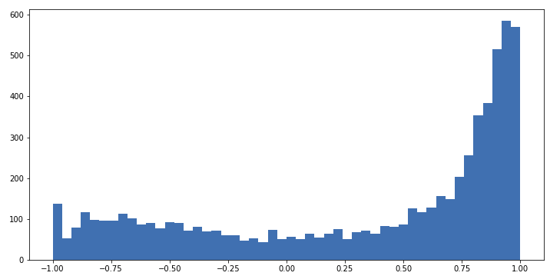

Machine learning can help us in two ways here. The first one is for prediction purposes. By using time series model, it is possible to capture the dynamics observed over time in the price of a stock. However, it should be used over the short-term, as this kind of model does rather poorly over the long-term. The second way machine learning can be useful is in clustering stocks by their characteristics.

The supervised learning portion modeled here uses the Box-Jenkins model, which uses both autoregressive and moving average regressors. By building models and comparing them, they can be compared in order to further improve the quality of the forecast obtained. The idea is that should it be possible to accurately project the price of a stock, it is possible to take investment decision and make a profit out of it. The unsupervised learning portion modeled here uses K-means clustering. The clustering exercise was done by looking at the volatility in the stocks variables, such as volume, daily spread of a stock, the average price level, and the daily difference between the open and the close. By capturing the volatility in those variables, it would be possible to look at those characteristic and develop investment strategies based on those. The strategies would serve to suit the needs of potential investors, based on 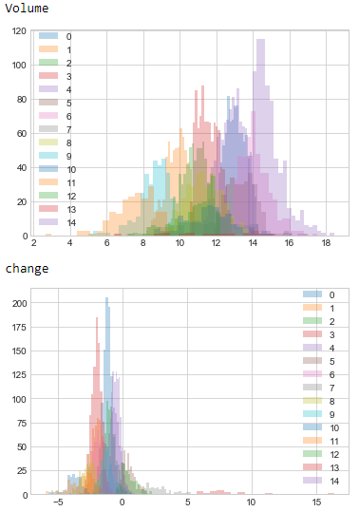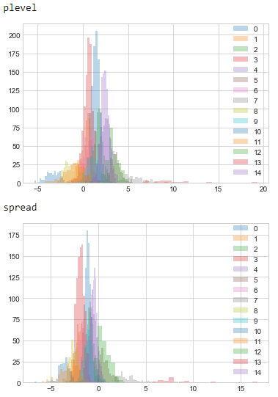their risk preferences.